Project Planning Phase
Project Planning Report — Product Backlog, Sprint Planning, Stories & Story Poin
Date | 01 October 2026 | Team ID | SWTID-2026-4755
Project Name | Implement Client Script & UI Policy (Incident) | Maximum Marks | 5 Marks

Planning objective: deliver a controlled Incident-entry workflow in which high-impact records receive stronger field rules, urgency is aligned automatically, incomplete records are blocked at save time, and direct State edits from a list are prevented. The plan below converts every documented implementation task into traceable backlog items and verification work.
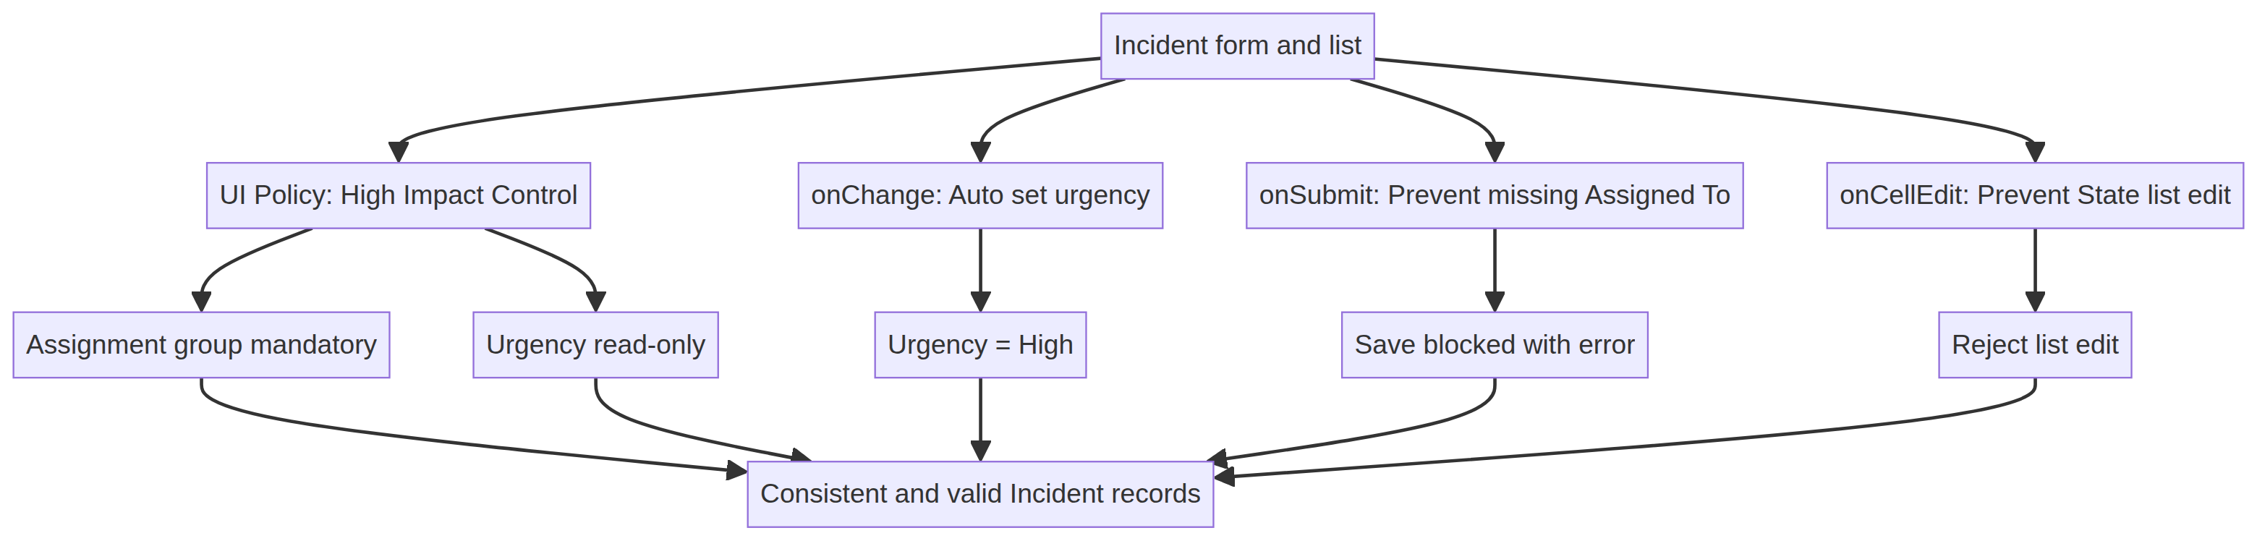
Figure 1. Planned control architecture derived from the project PDF.
Planning assumptions
- The four sprint dates are a planning schedule anchored to the requested report date; they are not claimed as historical execution dates.
- Story points use a relative Fibonacci-style scale: 1 = small configuration, 2 = straightforward script or policy action, 3 = integrated behavior, 5 = multi-step validation or evidence work.
- The team-member field is represented by the supplied team identifier because individual member names were not included in the project PDF.
1. Product Backlog, Sprint Schedule, and Estimation
The backlog is organized by functional requirement (epic). Each story is written as an outcome for the Incident user or administrator and is linked to the corresponding implementation task in the supplied project PDF.
Sprint | Functional Requirement (Epic) | Story No. | User Story / Task | Story Points | Priority | Team Members | Acceptance signal
Sprint 1 | High-impact UI control | US-01 | As an administrator, I can create the active High Impact Control UI Policy on Incident where Impact is 1 – High. | 3 | High | SWTID-2026-4755 | Policy evaluates correctly
Sprint 1 | High-impact UI control | US-02 | As an Incident user, I see Assignment group become mandatory when Impact is High, and the rule reverses when the condition is false. | 2 | High | SWTID-2026-4755 | Mandatory state reverses
Sprint 1 | High-impact UI control | US-03 | As an Incident user, I cannot edit Urgency while the High Impact Control policy is active. | 2 | High | SWTID-2026-4755 | Urgency is read-only
Sprint 2 | Urgency automation | US-04 | As an Incident user, Urgency is automatically set to High when Impact changes to High and an information message is shown. | 3 | High | SWTID-2026-4755 | Urgency becomes 1
Sprint 2 | Save-time validation | US-05 | As a service desk user, I receive a field-level error and cannot save a high-impact Incident when Assigned To is empty. | 5 | High | SWTID-2026-4755 | Save returns false
Sprint 3 | Interaction safety | US-06 | As an administrator, I can prevent direct State changes through list editing while keeping form-based State updates available. | 3 | Medium | SWTID-2026-4755 | callback(false) behavior
Sprint 4 | Acceptance evidence | US-07 | As a project evaluator, I can verify mandatory enforcement, successful save, reverse condition, list blocking, and form update behavior. | 5 | High | SWTID-2026-4755 | Five tests evidenced
Backlog total: 23 story points. The largest item is US-05 because it combines conditional logic, field-level messaging, and prevention of record submission. US-07 carries 5 points because it validates the complete integrated workflow rather than a single configuration object.
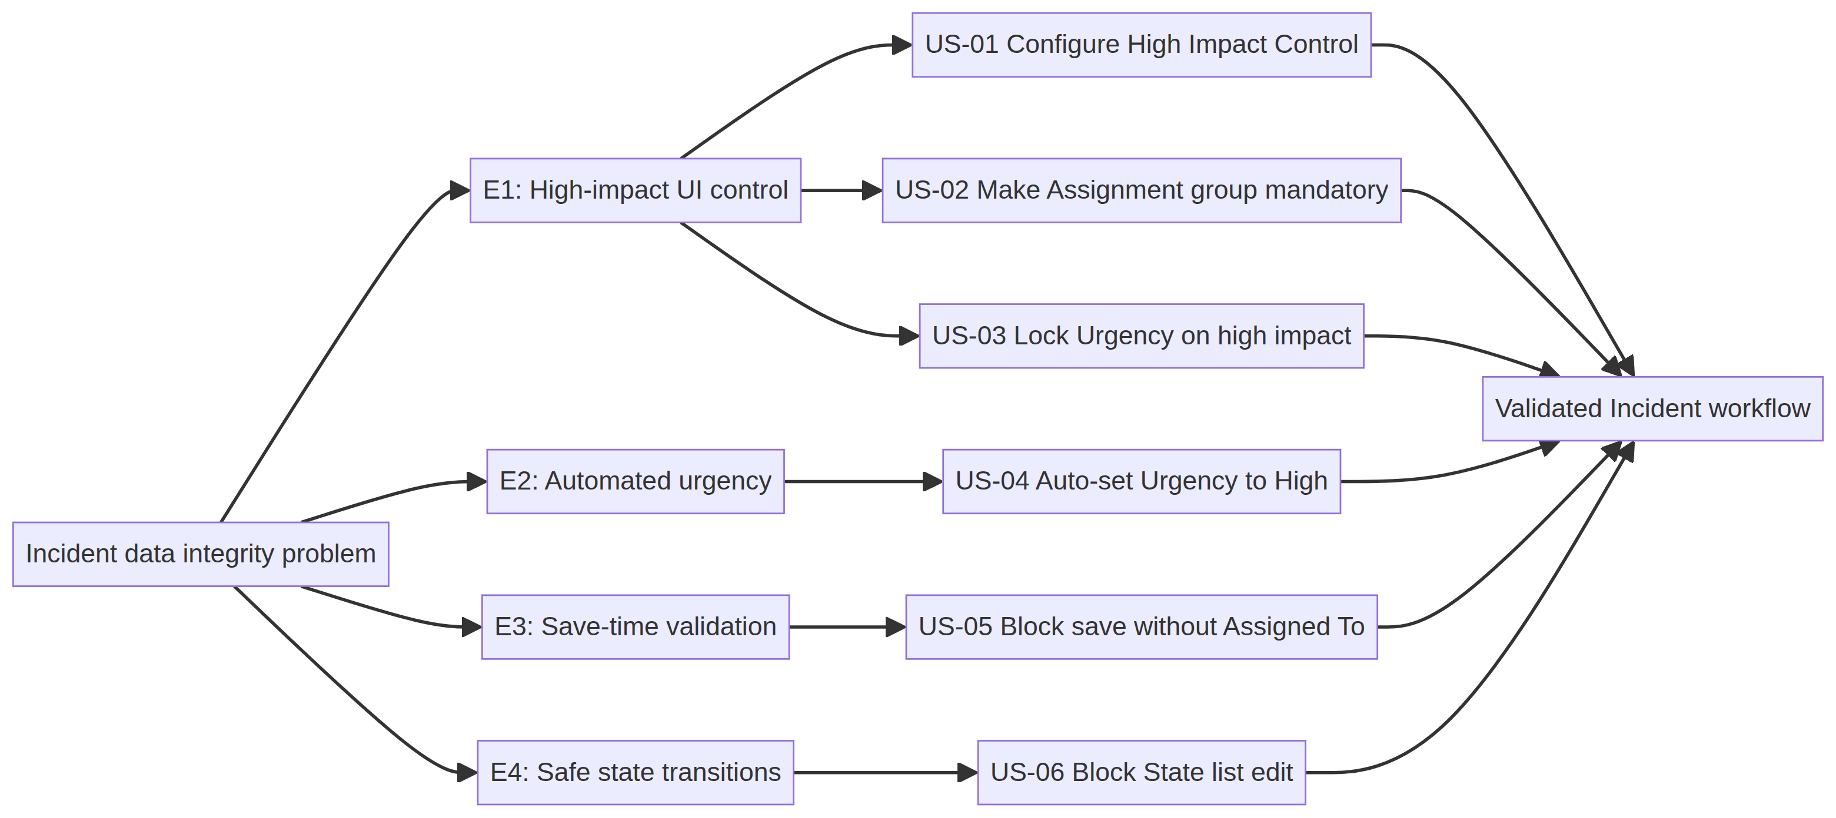
Figure 2. Epic-to-user-story traceability map for the planned implementation.
2. Project Tracker, Velocity, and Sprint Release Plan
The sprint tracker distributes the 23-point backlog across four six-day iterations. The plan deliberately places configuration foundations before scripts, interaction safeguards before integrated testing, and evidence capture in the final sprint.
Sprint | Total Story Points | Duration | Sprint Start Date | Sprint End Date (Planned) | Story Points Completed (Planned) | Sprint Release Date (Planned) | Definition of Done
Sprint-1 | 7 | 6 Days | 01 Oct 2026 | 06 Oct 2026 | 7 | 06 Oct 2026 | Policy and both UI Policy Actions configured and reviewed
Sprint-2 | 8 | 6 Days | 07 Oct 2026 | 12 Oct 2026 | 8 | 12 Oct 2026 | onChange and onSubmit scripts saved, reviewed, and smoke-tested
Sprint-3 | 3 | 6 Days | 13 Oct 2026 | 18 Oct 2026 | 3 | 18 Oct 2026 | onCellEdit State guard integrated with list-edit scenario
Sprint-4 | 5 | 6 Days | 19 Oct 2026 | 24 Oct 2026 | 5 | 24 Oct 2026 | Five acceptance scenarios executed and evidence assembled
Velocity calculation
Planned average velocity = total planned story points ÷ number of sprints = 23 ÷ 4 = 5.75 story points per sprint. The first two sprints carry more build work (7 and 8 points), while the final two focus on integration, defect correction, and acceptance evidence.
Metric | Sprint 1 | Sprint 2 | Sprint 3 | Sprint 4
Planned points | 7 | 8 | 3 | 5
Cumulative points | 7 | 15 | 18 | 23
Remaining points | 16 | 8 | 5 | 0
Primary outcome | Policy foundation | Client automation | List safety | UAT handover
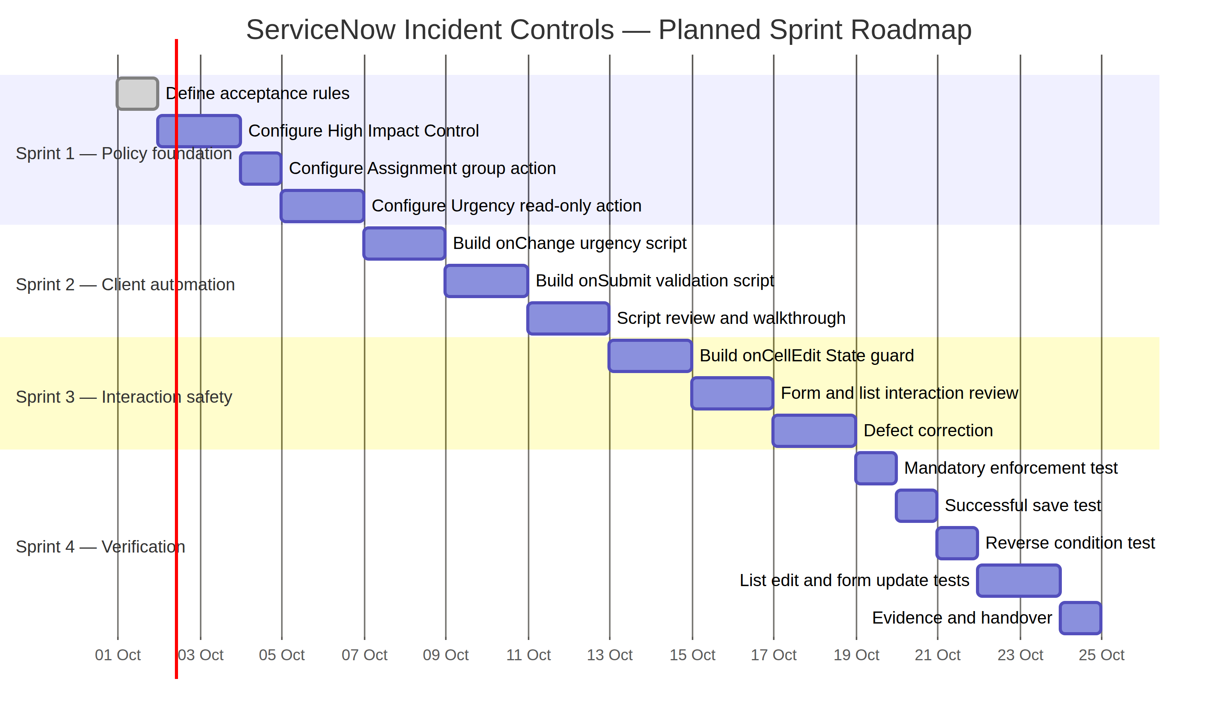
Figure 3. Planned sprint roadmap from policy foundation through UAT handover.
3. Burndown Chart and Delivery Controls
The planned burndown begins with 23 story points and reaches zero at the end of Sprint 4. The curve is intentionally front-loaded with policy and script work, then closes with validation and evidence. If the actual remaining work differs from the plan, the team should re-estimate unfinished stories rather than silently marking them complete.
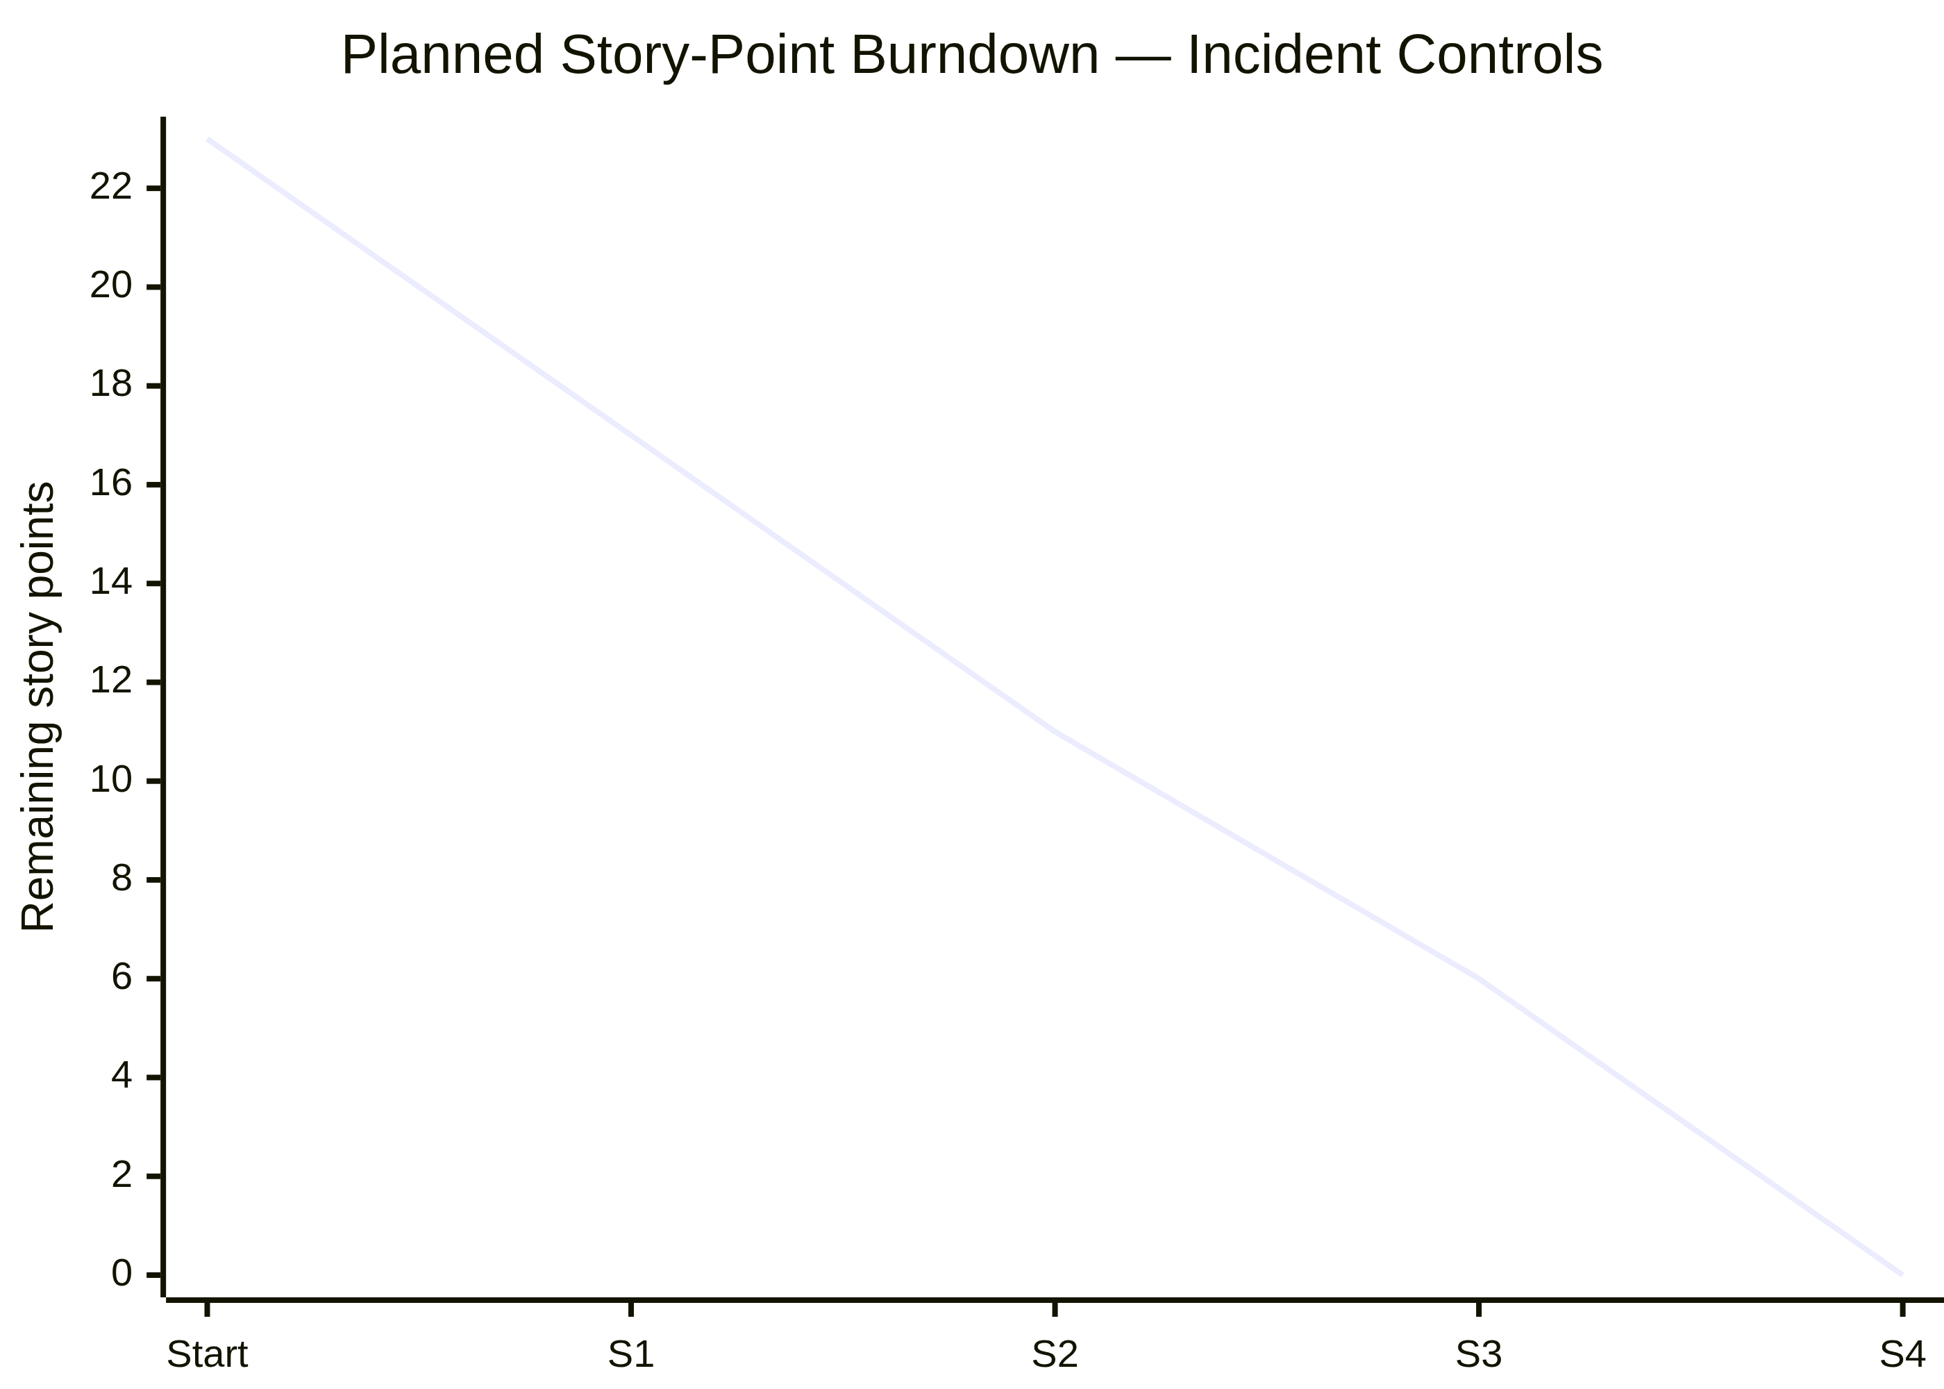
Figure 4. Planned story-point burndown across the four sprints.
4. Sprint Goals and Task Breakdown
Sprint | Goal | Planned tasks | Exit evidence
Sprint 1 | Establish conditional Incident behavior | Create High Impact Control; set Impact = 1; make Assignment group mandatory; enable Reverse if false; make Urgency read-only. | Policy record and two action configurations reviewed.
Sprint 2 | Automate urgency and protect save operation | Create onChange script for urgency; create onSubmit script for Assigned To; verify active status and script names. | Script walkthrough plus high-impact save checks.
Sprint 3 | Protect list-based State changes | Create onCellEdit script for State; verify alert and callback(false); confirm form editing remains allowed. | List-edit and form-update scenarios defined.
Sprint 4 | Validate end-to-end acceptance | Run mandatory enforcement, successful save, reverse condition, list edit blocking, and form-based update tests. | Completed evidence pack and evaluator handover.
Risk and mitigation plan
Risk | Impact on delivery | Mitigation | Owner
Policy reversal not verified | Users may see stale mandatory/read-only behavior | Include Impact High → Medium in Sprint 4 regression run. | SWTID-2026-4755
Assigned To validation conflicts with other rules | Valid Incident may be blocked or saved incorrectly | Test both empty and populated Assigned To paths. | SWTID-2026-4755
List edit guard affects only State | Other fields may remain editable by design | Limit onCellEdit script to State and validate form update separately. | SWTID-2026-4755
No live evidence attached | Evaluator cannot confirm runtime behavior | Capture screenshots or execution notes during Sprint 4. | SWTID-2026-4755
5. Planning Summary and Handover
This Phase 4 plan converts the supplied Implement Client Script & UI Policy (Incident) specification into a complete Agile delivery schedule. The work is sequenced so that the High Impact Control policy establishes the data rules, client scripts automate and validate the form, the onCellEdit script protects list interactions, and the final sprint proves that the combined behavior meets the project objective.
Planning measure | Planned value | Interpretation
Backlog scope | 7 user stories / 23 points | Covers all six implementation tasks plus integrated acceptance
Sprint plan | 4 × 6-day sprints | Build, automate, safeguard, then verify
Average velocity | 5.75 points per sprint | Baseline for this project plan
Planned release | 24 October 2026 | Target handover after Sprint 4 evidence
Team identifier | SWTID-2026-4755 | Used for ownership and planning traceability
Conclusion
The planned solution is lightweight, traceable, and aligned with the project PDF: a UI Policy controls conditional field behavior, an onChange Client Script aligns urgency, an onSubmit Client Script prevents incomplete high-impact records, and an onCellEdit Client Script blocks unsafe State list edits. With the backlog, sprint schedule, velocity baseline, burndown, risks, and exit evidence defined, the project is ready to proceed into implementation and subsequent User Acceptance Testing.

